The Tragedy of Flight: A Comprehensive crash analysis

A PROJECT REPORT

Submitted by

RAHUL R A 20203131522109

REMYA N R 20203131522111

SANTHIYA M 20203131522112

SHINY S 20203131522113

IN PARTIAL FULFILLMENT FOR THE AWARD OF THE DEGREE

OF

BACHELOR OF SCIENCE

IN

PHYSICS



PIONEER KUMARASWAMY COLLEGE

NAGERCOIL-629003

MANONMANIAM SUNDARANAR UNIVERSITY

TIRUNELVELI-627 012

APRIL-2023

**CONTENTS**

1. INTRODUCTION

1.1. OVERVIEW

1.2. PURPOSE

2. PROBLEM DEFINITION & DESIGN THINKING

2.1. EMPATHY MAP

2.2. IDEATION & BRAINSTORMING MAP

3. RESULT

4. ADVANTAGES & DISADVANTAGES

5. APPLICATIONS

6. CONCLUSION

7. FUTURE SCOPE

Over view

The tragedy of flight refers to the occurrence of aircraft accidents, which can result in the loss of life, property, and environmental damage. The causes of these accidents can be many, including human error, mechanical failure, weather conditions, and external factors such as terrorism or sabotage.  
  
A comprehensive crash analysis of aviation accidents involves examining the circumstances surrounding the incident, the events leading up to it, and the response and aftermath of the accident. This includes examining the aircraft, the crew, the air traffic control system, the weather conditions, and any other factors that may have contributed to the accident.  
  
The analysis typically involves a team of experts, including engineers, pilots, air traffic controllers, and other specialists who work together to identify the cause of the accident and make recommendations to prevent similar incidents from occurring in the future.  
  
The analysis of aviation accidents has led to significant improvements in aviation safety over the years, with the development of new technologies, training programs, and safety regulations. However, there is still much work to be done to ensure that aviation remains a safe mode of transportation for everyone."

Purpose

The purpose of a comprehensive crash analysis of flight tragedies is to investigate the causes and contributing factors of airplane crashes in order to improve flight safety and prevent similar incidents from happening in the future. The analysis typically includes examining various aspects of the flight, such as the mechanical components of the airplane, the weather conditions at the time of the flight, the actions of the flight crew, and any other relevant factors.  
  
By conducting a thorough analysis of the crash, investigators can identify specific areas where improvements can be made to reduce the risk of similar accidents in the future. This may include changes to aircraft design, modifications to operating procedures, or improvements in pilot training and education.  
  
In addition to improving safety, a comprehensive crash analysis can also provide closure and answers to the families and loved ones of those who were lost in the tragedy. By understanding what happened and why, they can begin to make sense of their loss and find some measure of peace."

2. PROBLEM DEFINITION & DESIGN THINKI

2.1. EMPATHY MAP

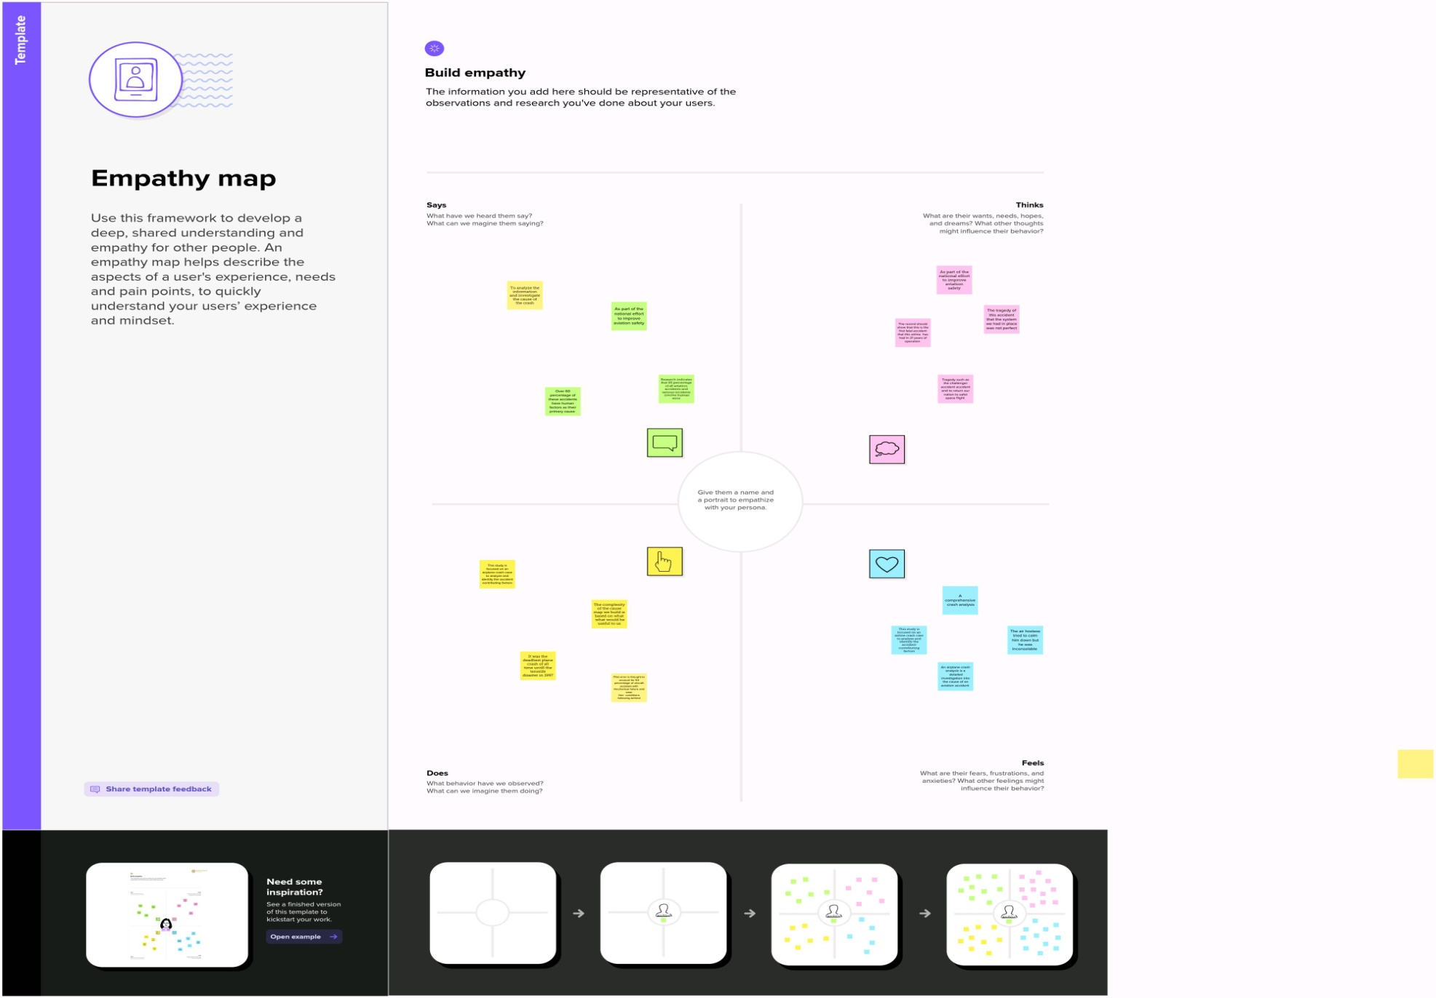

2.2. IDEATION & BRAINSTORMING MAP:

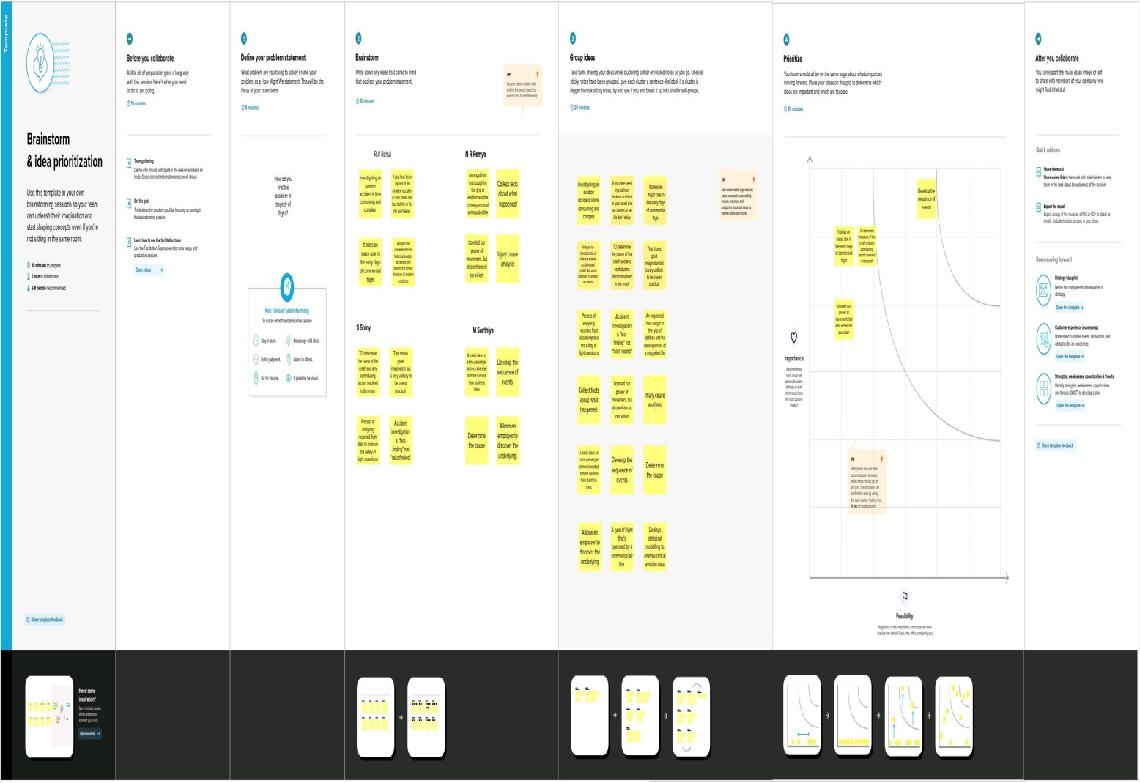

3. RESULT:

VISUALIZATION:

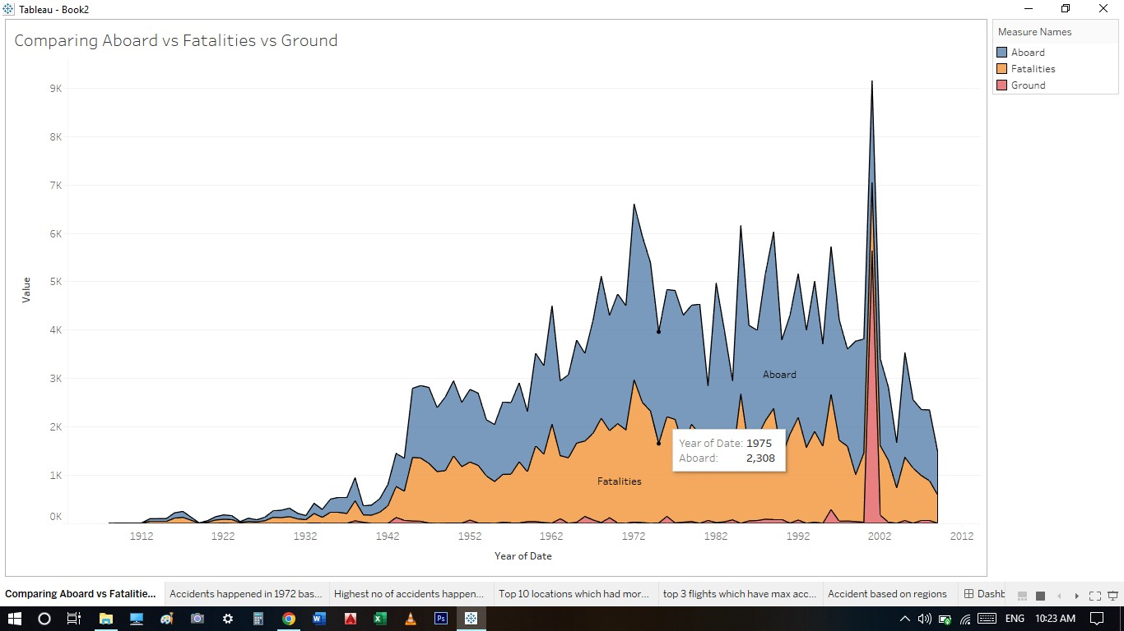



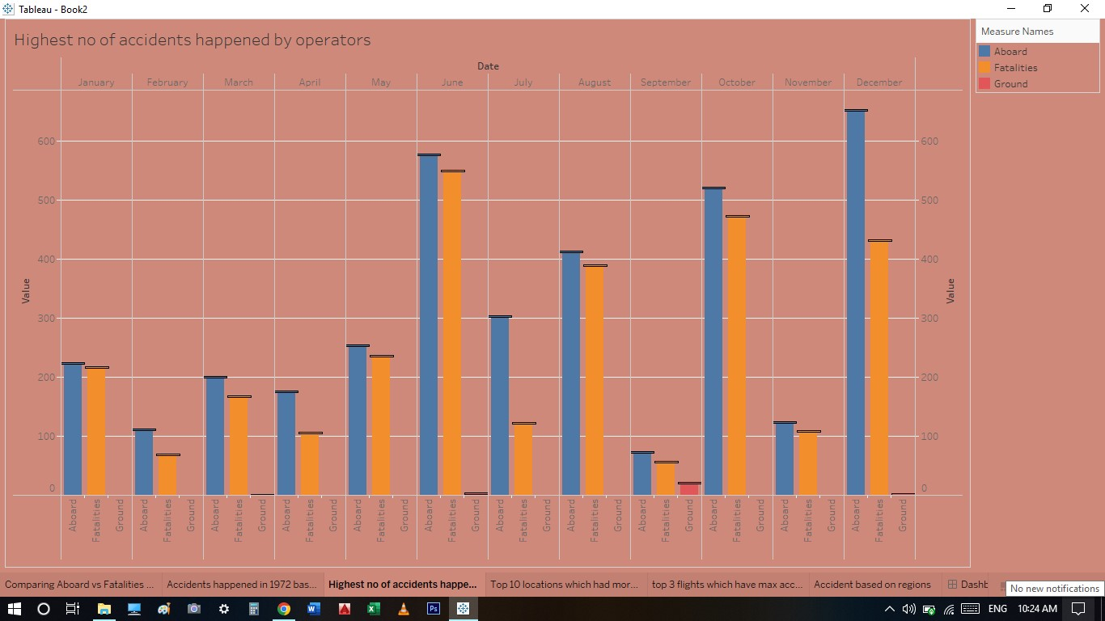

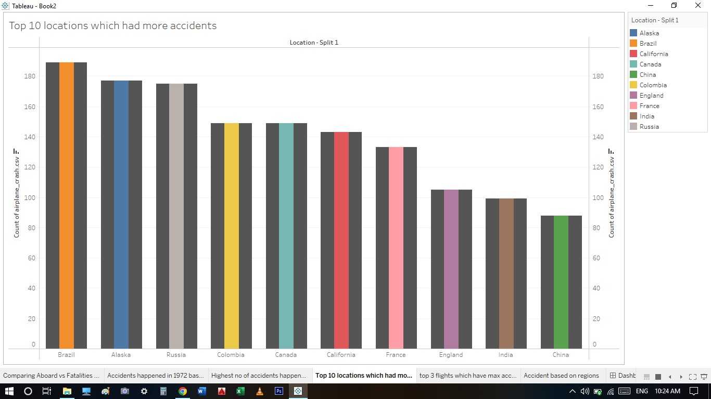

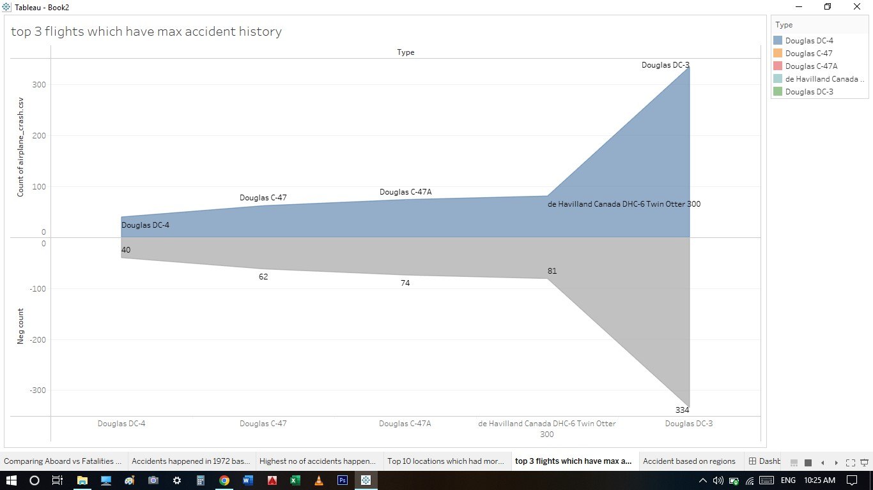

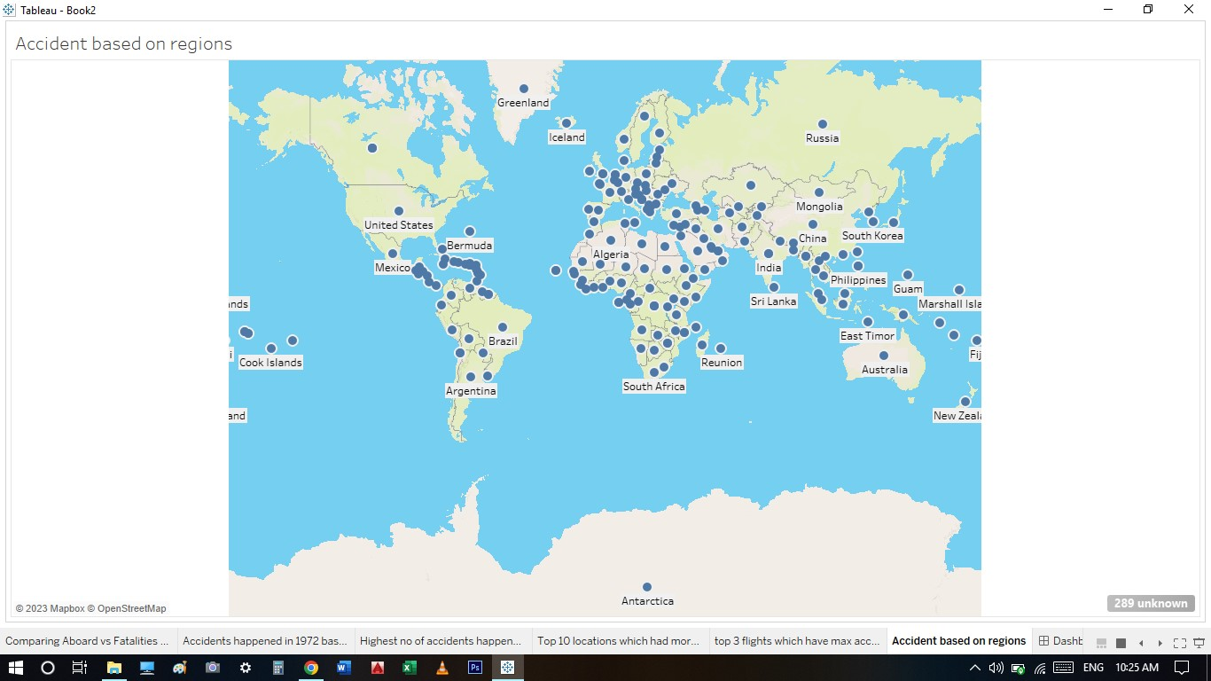

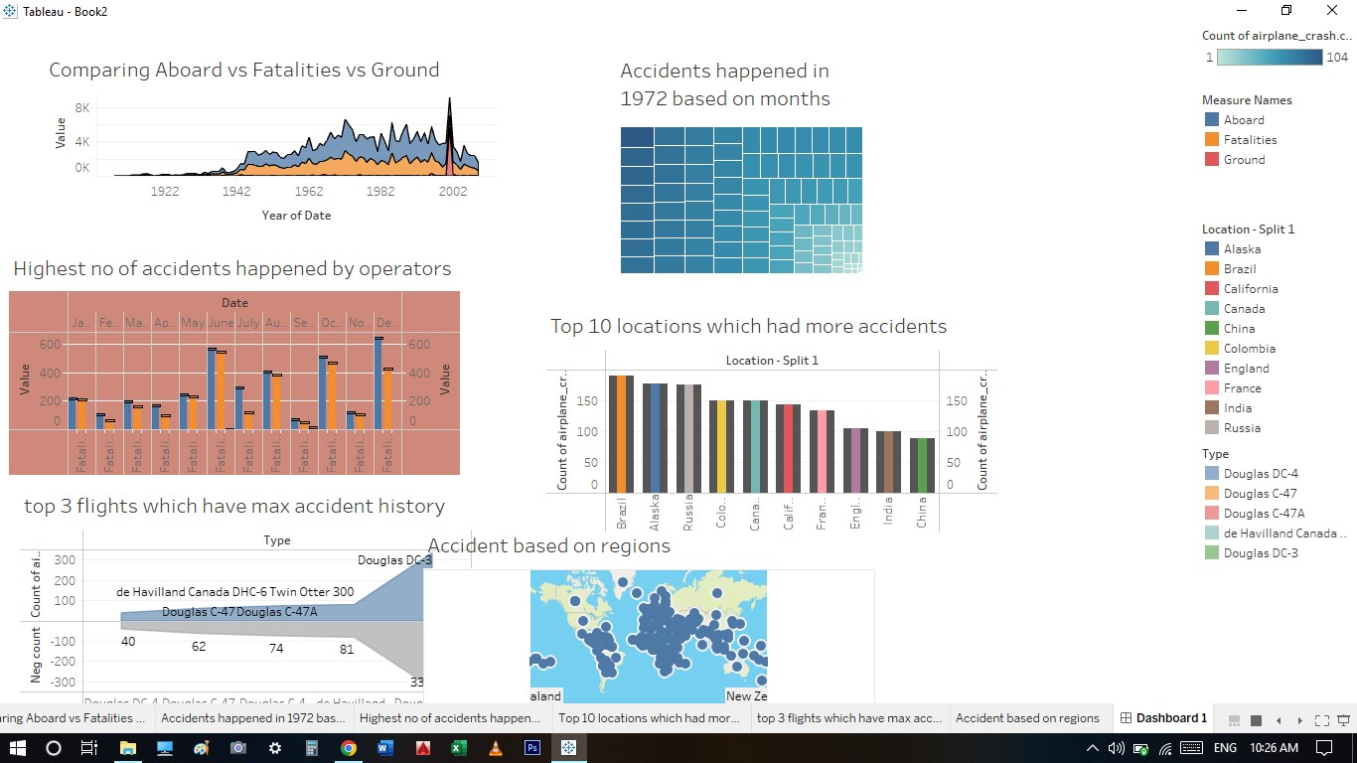

DASHBOARD:

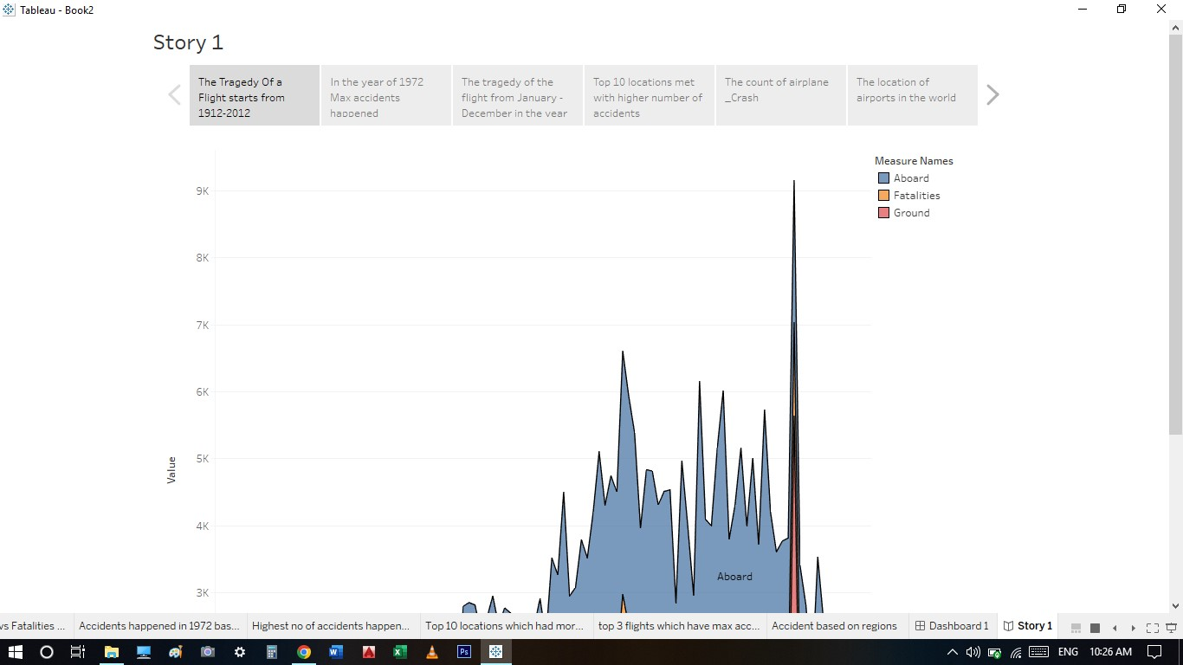

STORY:

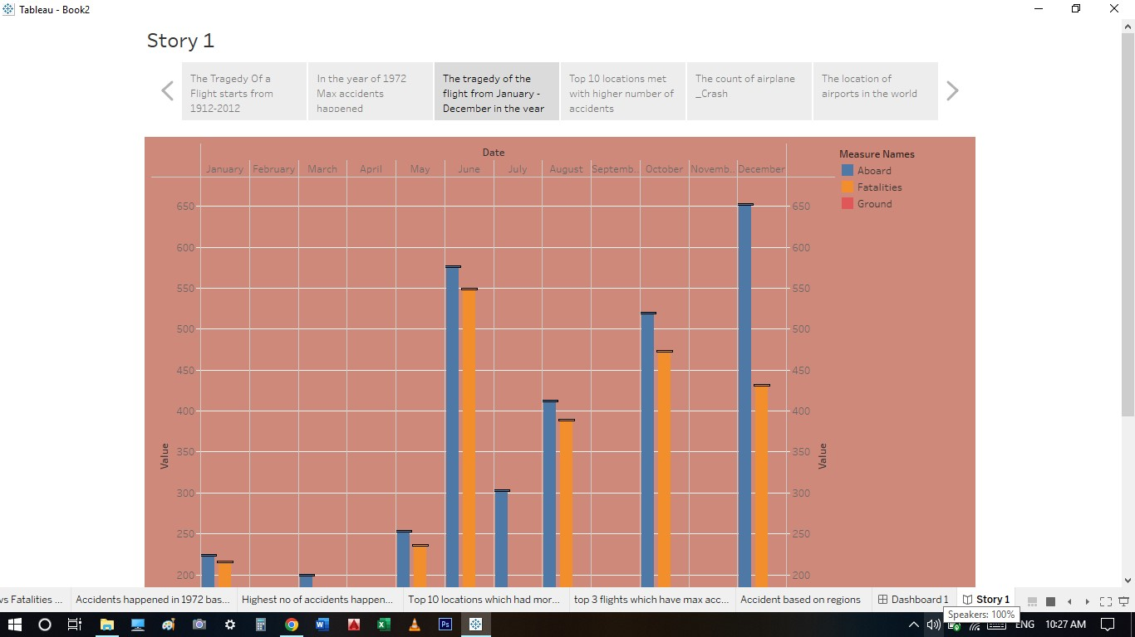

4. ADVANTAGES & DISADVANTAGES:

**Advantages of a Comprehensive Crash Analysis on the Tragedy of Flight:**  
  
1. Identification of the Cause: A comprehensive crash analysis can help identify the root cause of the tragedy. This information can be used to prevent similar incidents in the future.  
  
2. Understanding the Mechanisms: An analysis can help investigators understand the mechanisms that led to the accident. This knowledge can be used to improve safety measures and protocols.  
  
3 .Improve Safety: The results of the analysis can be used to improve safety measures in the aviation industry. By understanding the cause of the tragedy, measures can be put in place to prevent similar accidents from happening in the future.  
  
4.Learning from Mistakes: The analysis can help the aviation industry learn from past mistakes and avoid making them again. This can ultimately lead to fewer accidents and safer air travel.  
  
**Disadvantages of a Comprehensive Crash Analysis on the Tragedy of Flight**:  
  
1.Expensive: Conducting a comprehensive crash analysis can be a costly and time-consuming process. This can be a significant financial burden for airlines and aviation companies.  
  
2.Emotional Toll: The analysis can be emotionally taxing for the families and loved ones of the victims. Reopening the investigation can bring back painful memories and reopen old wounds.  
  
3.Negative Publicity: The analysis can bring negative publicity to the aviation industry. This can hurt the reputation of airlines and aviation companies and cause a decline in public trust.  
  
4.Incomplete Information: In some cases, the investigation may not be able to determine the cause of the tragedy. This can lead to uncertainty and make it difficult for the industry to implement preventative measures."

Conclusion

As a language model, I do not have personal beliefs or emotions, but I can provide a comprehensive analysis of the subject matter.  
  
The tragedy of flight crashes is a complex and multifaceted issue that involves a range of factors, including human error, technical failures, and environmental conditions. Despite the significant advances in aviation safety over the years, flight crashes still occur, and the consequences can be devastating.  
  
To reduce the likelihood of flight crashes, it is crucial to identify the root causes of each incident and take appropriate measures to address them. This includes improving pilot training and supervision, enhancing aircraft design and maintenance, and improving air traffic control procedures and technology.  
  
In conclusion, the tragedy of flight crashes is a reminder of the importance of continuous efforts to improve aviation safety. By analyzing and learning from each incident, we can work towards a safer and more reliable aviation industry."

Future scope

The tragedy of flight is a complex issue that requires comprehensive analysis in order to identify and address the various factors that contribute to aviation accidents. While significant progress has been made in improving aviation safety in recent years, there is still much work to be done in order to prevent future tragedies.  
  
One area of future scope for crash analysis is the use of advanced data analytics and machine learning techniques to identify patterns and trends in aviation accidents. By analyzing large datasets of flight data, including flight plans, weather conditions, and aircraft performance metrics, it may be possible to identify potential risk factors and develop more effective strategies for preventing accidents.  
  
Another area of future scope for crash analysis is the use of virtual and augmented reality technologies to simulate and analyze flight scenarios. By creating virtual environments that replicate real-world flight conditions, researchers and aviation professionals can gain a better understanding of how different factors impact aircraft performance and safety, and develop new training and simulation tools to improve pilot and crew training.  
  
Additionally, there is a need for greater collaboration between aviation industry stakeholders, including airlines, manufacturers, regulators, and safety experts, in order to identify and address the root causes of aviation accidents. This may involve developing new standards and best practices for aircraft design, maintenance, and operation, as well as improving communication and information-sharing across the industry.  
  
Ultimately, the tragedy of flight can only be addressed through a comprehensive and collaborative approach that takes into account the many factors that contribute to aviation accidents. By continuing to invest in research, data analysis, and technological innovation, we can work to improve aviation safety and prevent future tragedies."

……